CS5351 Software Engineering
2025/2026 Semester A
Exercise on Modern Code Review (MCR)

I. Background on MCR
- MCR is a lightweight and tool-based code review of code change (not the whole piece of code!)
  - It is the norm for many software development projects
- Characteristics of MCR
  - Informal;
  - Tool-based logistics;
  - Asynchronous;
  - Focused on reviewing code changes;
  - Lighter weight than code inspection.
- Main Ideas
  - Author A makes a patch^{[1]} P on a code block C to address some problems and sends the patch P via e-channel (e.g., email, Whatsapp, WeChat, or review tool) to a set of reviewers R
  - Each reviewer R evaluates P: either deems P good or rejects P
  - Author A commits P; post-commit reviewer by other Rs possible.
- Authors and reviewers exchange ideas, find bugs, and discuss alternative solutions to better design the structure of a submitted code change.
- A case study and more information about MCR can be found in the following paper^{[2]}.

- Patch refers to the diff file of two pieces of code. See the example in the following link: https://www.cyberciti.biz/faq/appy-patch-file-using-patch-command/
- Sadowski, Caitlin, Emma Söderberg, Luke Church, Michal Sipko, and Alberto Bacchelli. "Modern code review: a case study at google." In Proceedings of the 40th International Conference on Software Engineering: Software Engineering in Practice, pp. 181-190. 2018.

II. In-Class Activity MCR-2
1. Each student has a role as follows:
- Author A of the code: 1 student
- Reviewers R: no pre-defined role
- Use GitHub for review, and Author A should conduct the following steps from step 2 to step 6 for the preparation of the activity MCR-2.

2. [all students] Step to sign up a GitHub account if that student has an account yet
Create a GitHub account (https://github.com) (If you have one, just log in)
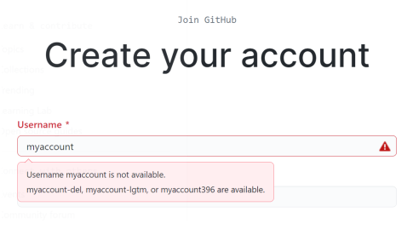

3. [Author A] Nominate one student among all students in the team to serve as the author (Author A) for this step. Author A creates a project (as a new repository)
- Create a project for the exercise
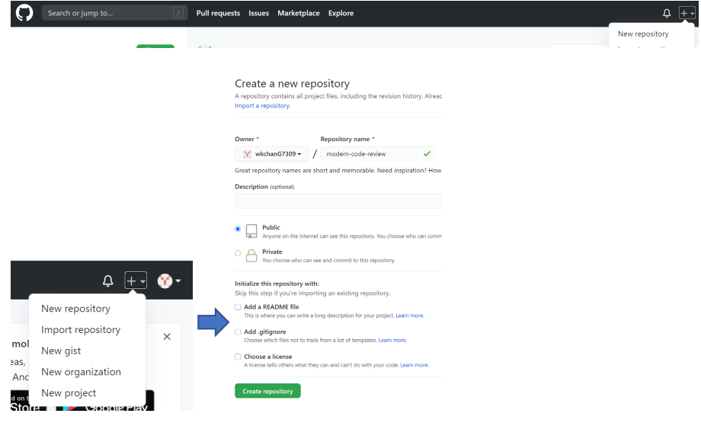

4. Step for Author A to invite other students to join the project
- [All but Author A] Inform Author A about your GitHub ID
  - Tell Author A to set you as a collaborator.

- [Author A] Invite all your teammates as the project’s collaborators.
a. Press [Settings]
b. Select [Collaborators]
c. Press [Add people]
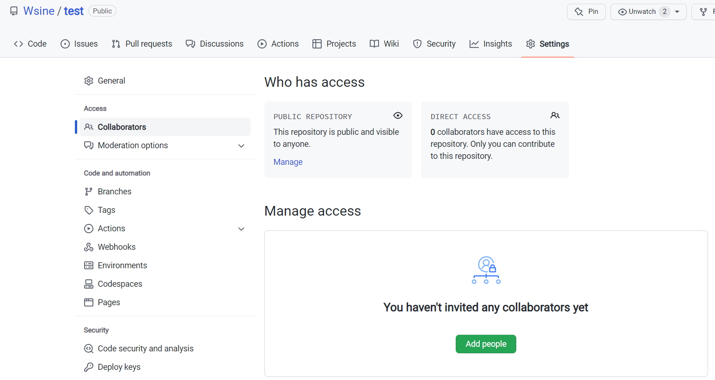

5. [All but Author A] Step for other students to check their mailboxes to join the project
- Check your email and accept the collaboration invitation from Author A.
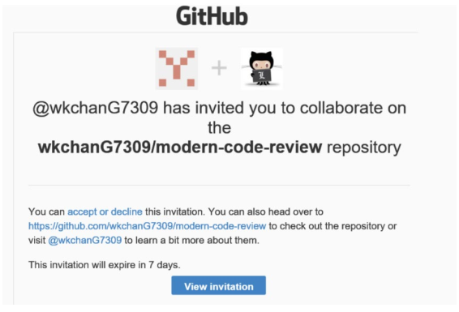

6. Step to check in the original code
- [Author A] Create a new file in the GitHub project and check in the original code with the following steps.
  - Go to [Code] menu
  - Press [creating a new file]
  - Name your file as mcr.cpp
  - Copy and paste the code listing from the shared Word document for Author A to the editor in GitHub.
  - Press [Commit new file]
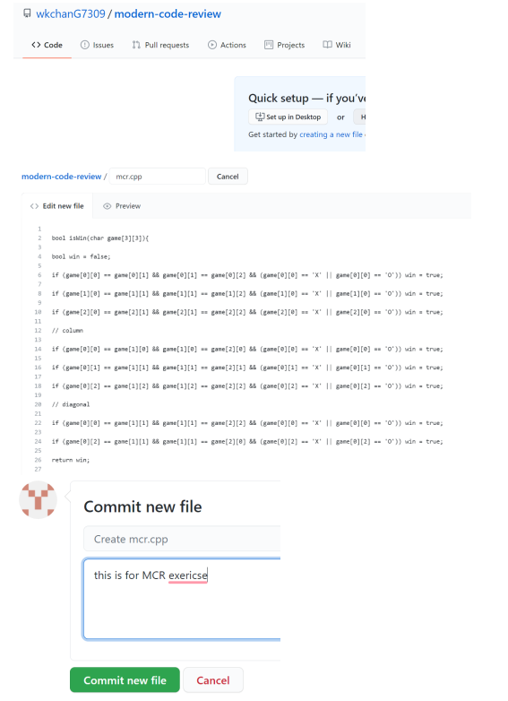

7. [00-10 minutes] Author A prepares the patch P for the code C & C1 (produced in your MCR-1 exercise), and sends the patch P with some explanation notes to the e-channel
- Note: A patch is the diff file of the two pieces of code

7.1 [Author A] Make changes and Check out the code
- Click the mcr.cpp file in GitHub.
- Press [edit file] according to the reviewers’ comments.
- Modify the mcr.cpp according to the change required.
- Go to the bottom of the current webpage
- Important: Check [Create a new branch for this commit and start a pull request.] in order to create a Patch P.
- Press [Propose changes]
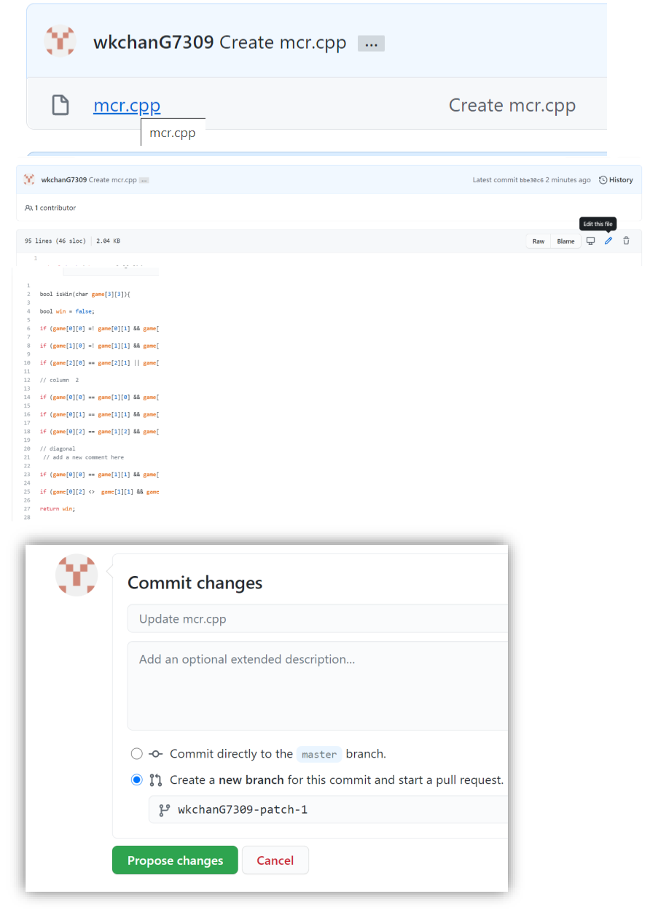

7.2 [Author A] Check in the revised code
- Press [Create pull request]
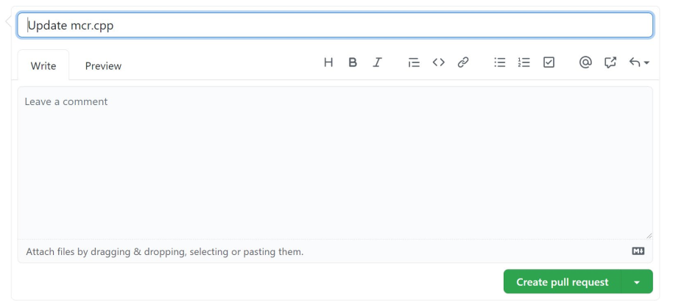

8. [10-25 minutes] R reviews P and gives comments in the e-channel and posts comments
- Navigate to a webpage to review the "patch" and project members should comment on the changes.

8.1 [All students] Press [Pull request] menu item in this project. You will see the following screen. Click the “Update mcr.cpp”.
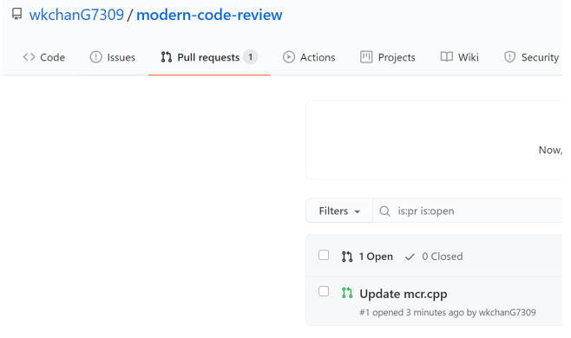

8.2 [All students] Press [File changed]
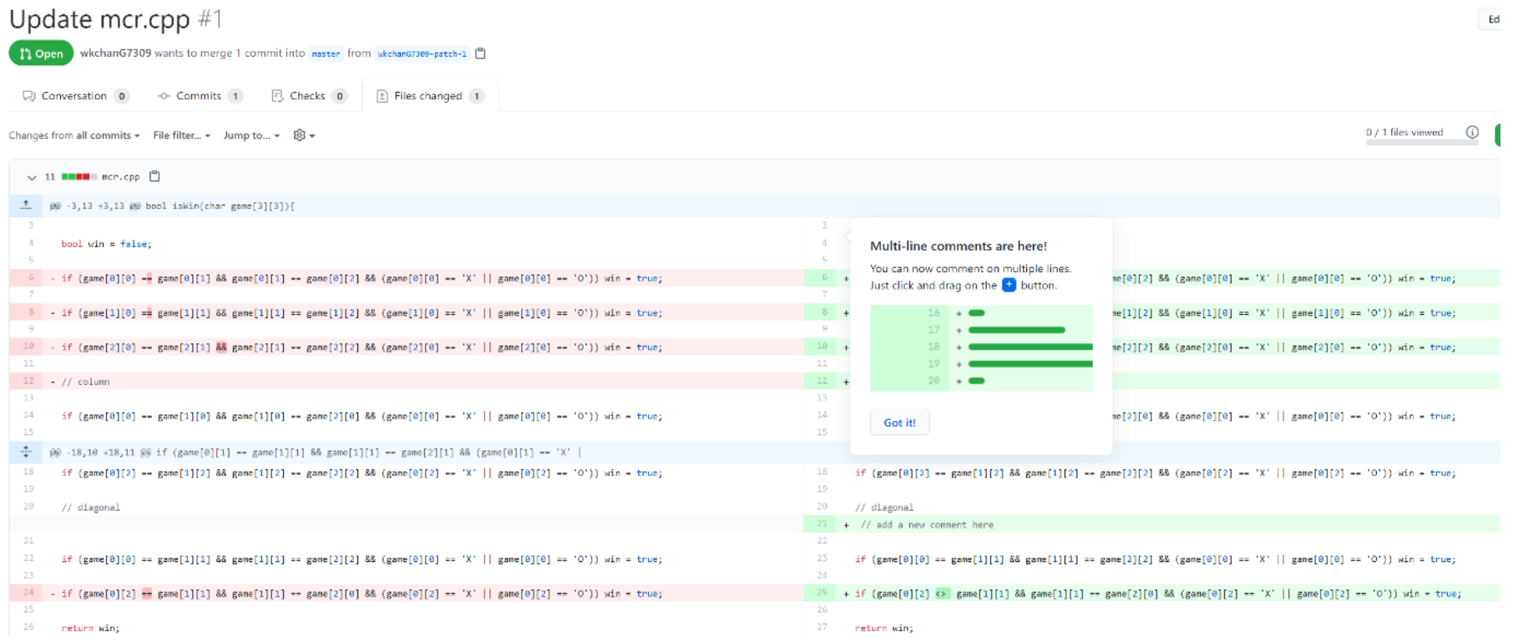

8.3 [All students] Add your comments by [+] button for a specific line of code, then press [Review changes], write your informative comments in the “Leave a comment” text box, followed by [Submit review] as comments. One example on line 6 is as below.
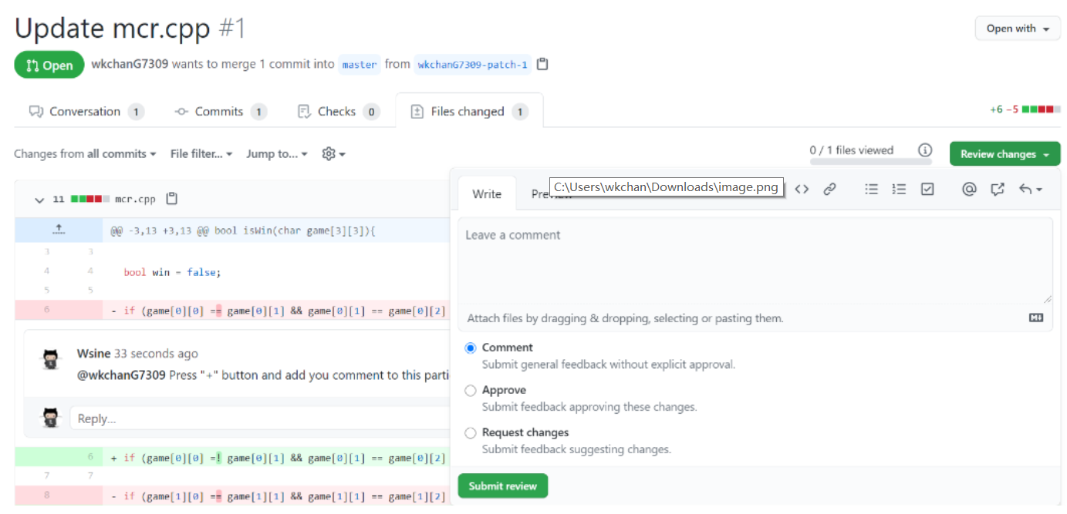

9. [10-25 minutes] Author A answers issues and provides clarifications made by R and sends out the revised patch P’ iteratively.
9.1 [All students] Start a conversation by pressing [Conservation] or you can start reviewing other parts of the code.
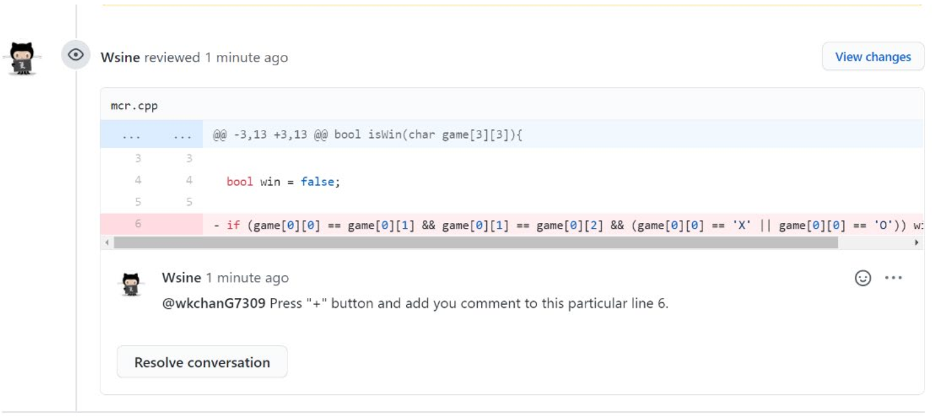

9.2 [Author A] Change the code according to the consensus.
• Press [file changes]
• Press […] in mcr.cpp, and then press [edit file] in the pop-up menu.
• Edit the file
• Select “Commit directly to the <<YOUR-PATCH>> branch.”
• Press [Commit changes]
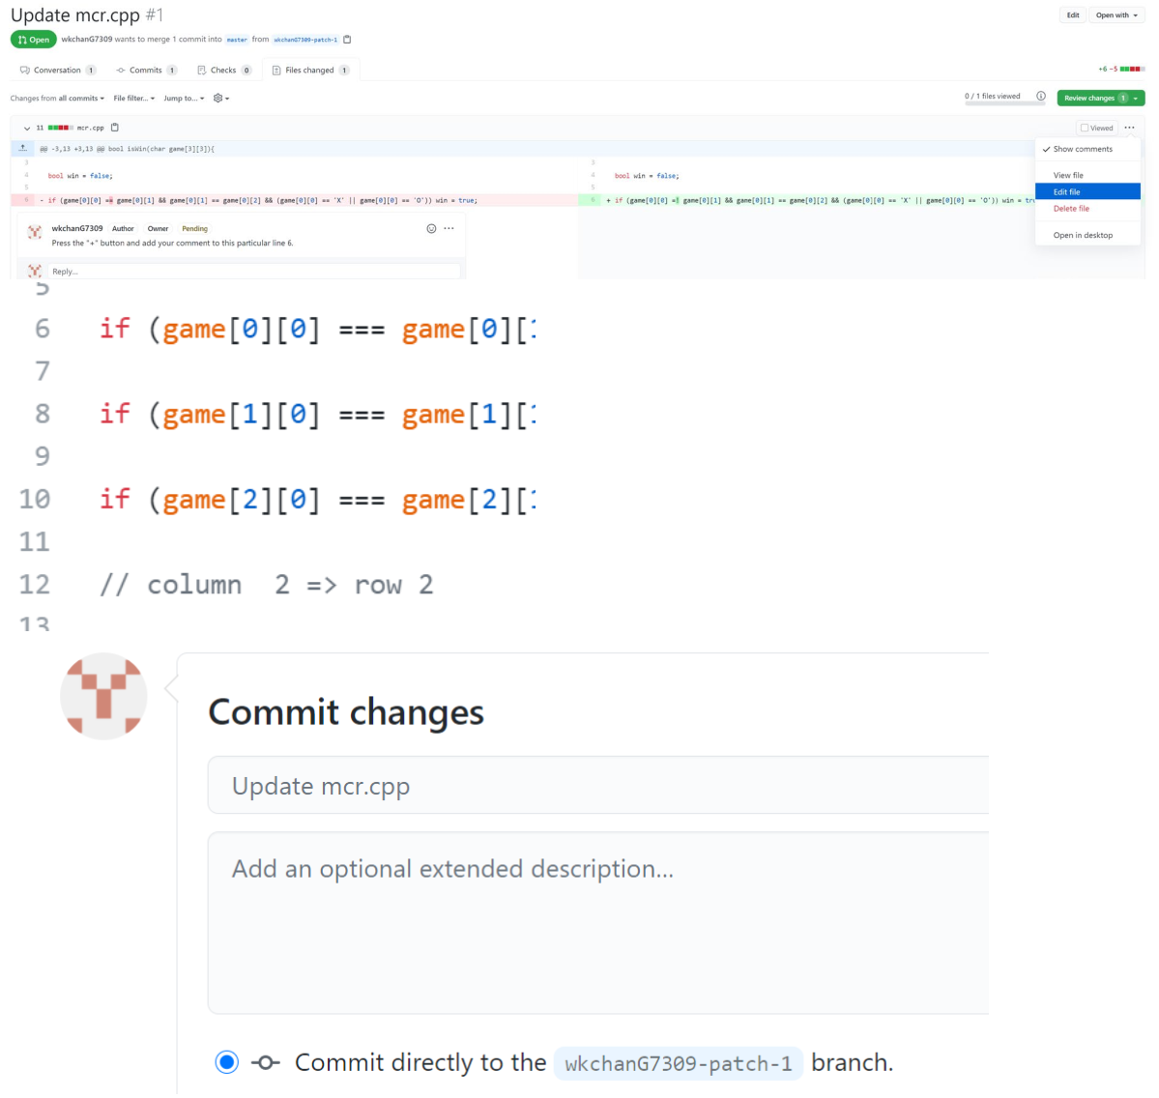

9.3 [All students] Repeat steps 8-9 until the review session is ended.

10. [25-30 minutes] R approves P’ and Author A applies the final patch P’ to get the final corrected code C2

10.1 [Author A] After all reviews and revisions are done, the author goes to [Conversation] followed by pressing [Merge pull request].
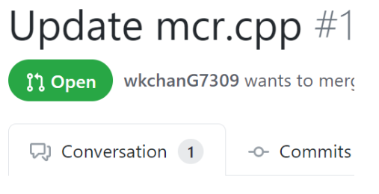
10.2 [All students] Check the repository to confirm the final patch P’ updated in the main branch as expected.
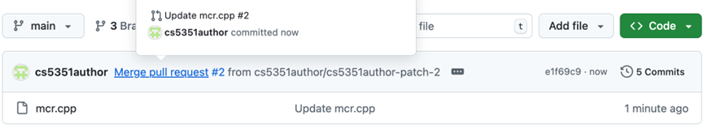
11. [At the 30th minute] Author A posts the corrected C2 to Canvas [Discussions] in addition to using C2 as a commit for the project.

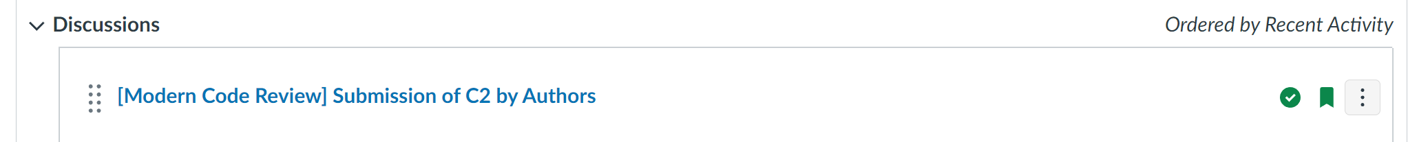

Code Listing for Step 6

bool isWin(char game[3][3]){
bool win = false;
if (game[0][0] == game[0][1] && game[0][1] == game[0][2] && (game[0][0] == 'X' || game[0][0] == 'O')) win = true;
if (game[1][0] == game[1][1] && game[1][1] == game[1][2] && (game[1][0] == 'X' || game[1][0] == 'O')) win = true;
if (game[2][0] == game[2][1] && game[2][1] == game[2][2] && (game[2][0] == 'X' || game[2][0] == 'O')) win = true;
// column
if (game[0][0] == game[1][0] && game[1][0] == game[2][0] && (game[0][0] == 'X' || game[0][0] == 'O')) win = true;
if (game[0][1] == game[1][1] && game[1][1] == game[2][1] && (game[0][1] == 'X' || game[0][1] == 'O')) win = true;
if (game[0][2] == game[1][2] && game[1][2] == game[2][2] && (game[0][2] == 'X' || game[0][2] == 'O')) win = true;
// diagonal
if (game[0][0] == game[1][1] && game[1][1] == game[2][2] && (game[0][0] == 'X' || game[0][0] == 'O')) win = true;
if (game[0][2] == game[1][1] && game[1][1] == game[2][0] && (game[0][2] == 'X' || game[0][2] == 'O')) win = true;
return win;
}

int main(){
int i, j;
char game[3][3] = {' '}; // Tic-tac-toe
char player1 = 'X';
char player2 = 'O';
bool turn = true; // false for player 1's turn, true for player 2's turn. Player 1 first.
cout << "X = Player 1" << endl << "O = Player 2" << endl;
for (int n=0; n<9; n++){
turn = !turn; // use the not-operator to change true to false or false to true.
if (turn == false)
cout << "Player 1: ";
else
cout << "Player 2: ";
cout << "Which cell to mark? i:[1..3], j:[1..3]: ";
cin >> i >> j;
if (turn == false)
game[i][j] = 'X';
else
game[i][j] = 'O';
if (isWin(game)){
cout << "Win!" << endl;
break; // need to terminate the problem
}
}
if (i==3) // all celles with i=0 to 2 have been inputted above but no winner yet
cout << "Tie!" << endl;

// show the game to console
cout << game[0][0] << " " << game[0][1] << " " << game[0][2] << endl;
cout << game[1][0] << " " << game[1][1] << " " << game[1][2] << endl;
cout << game[2][0] << " " << game[2][1] << " " << game[2][2] << endl;
return 0;
}

the code listing is also avaliabe on the last two pages of this document.

